TYPICAL SPECIFICATIONS
ROLLER STORAGE TRUNNIONS
For Ton Containers

SPECIFICATION SECTION 11261 - Chlorination Equipment

A quantity of ____ roller storage trunnion set[s] shall be provided for securely storing ton containers of [chlorine/sulfur dioxide].

A set shall consist of two (2) trunnion blocks, each with two (2) rollers. Trunnion blocks shall be fabricated of ASTM-A36 steel and finished with 2-part epoxy powder coating to resist corrosion.

Each trunnion block shall have two (2) rollers made of ultra high molecular weight polyethylene (UHMW-PE) with stainless steel axles for ease of tank rotation. No periodic grease application shall be required due to the self-lubricating properties of UHMW-PE.

Trunnion blocks shall have slotted holes in each end to allow tolerance in anchor locations.

Trunnions shall carry a minimum of Five (5) Year Warranty. “Limited” Warranties shall be considered unacceptable.

Trunnions shall be Model 21L as manufactured by FORCE FLOW, 2430 Stanwell Dive, Concord, CA 94520 USA (www.forceflow.com), or equal.

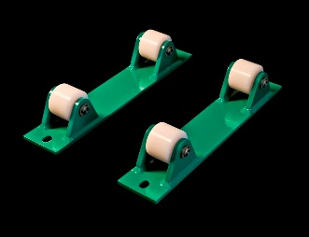
Model Description
21L Roller Storage Trunnion Set
(One set secures one container)

For more information on roller storage trunnions, see Bulletin 208.

